**Name:** Meet Vipul Gandhi

**PRN:** 2020BTECS00112

**Class:** Final Year (Computer Science and Engineering)

**Year:** 2023-24 **Semester:** 1

**Course:** High Performance Computing Lab

**Practical No. 2**

**Title of practical: Study and implementation of basic OpenMP clauses**

Implement following Programs using OpenMP with C:

1. Vector Scalar Addition
2. Calculation of value of Pi

Analyse the performance of your programs for different number of threads and Data size.

**Problem Statement 1:** Vector Scalar Addition

**Screenshots:**

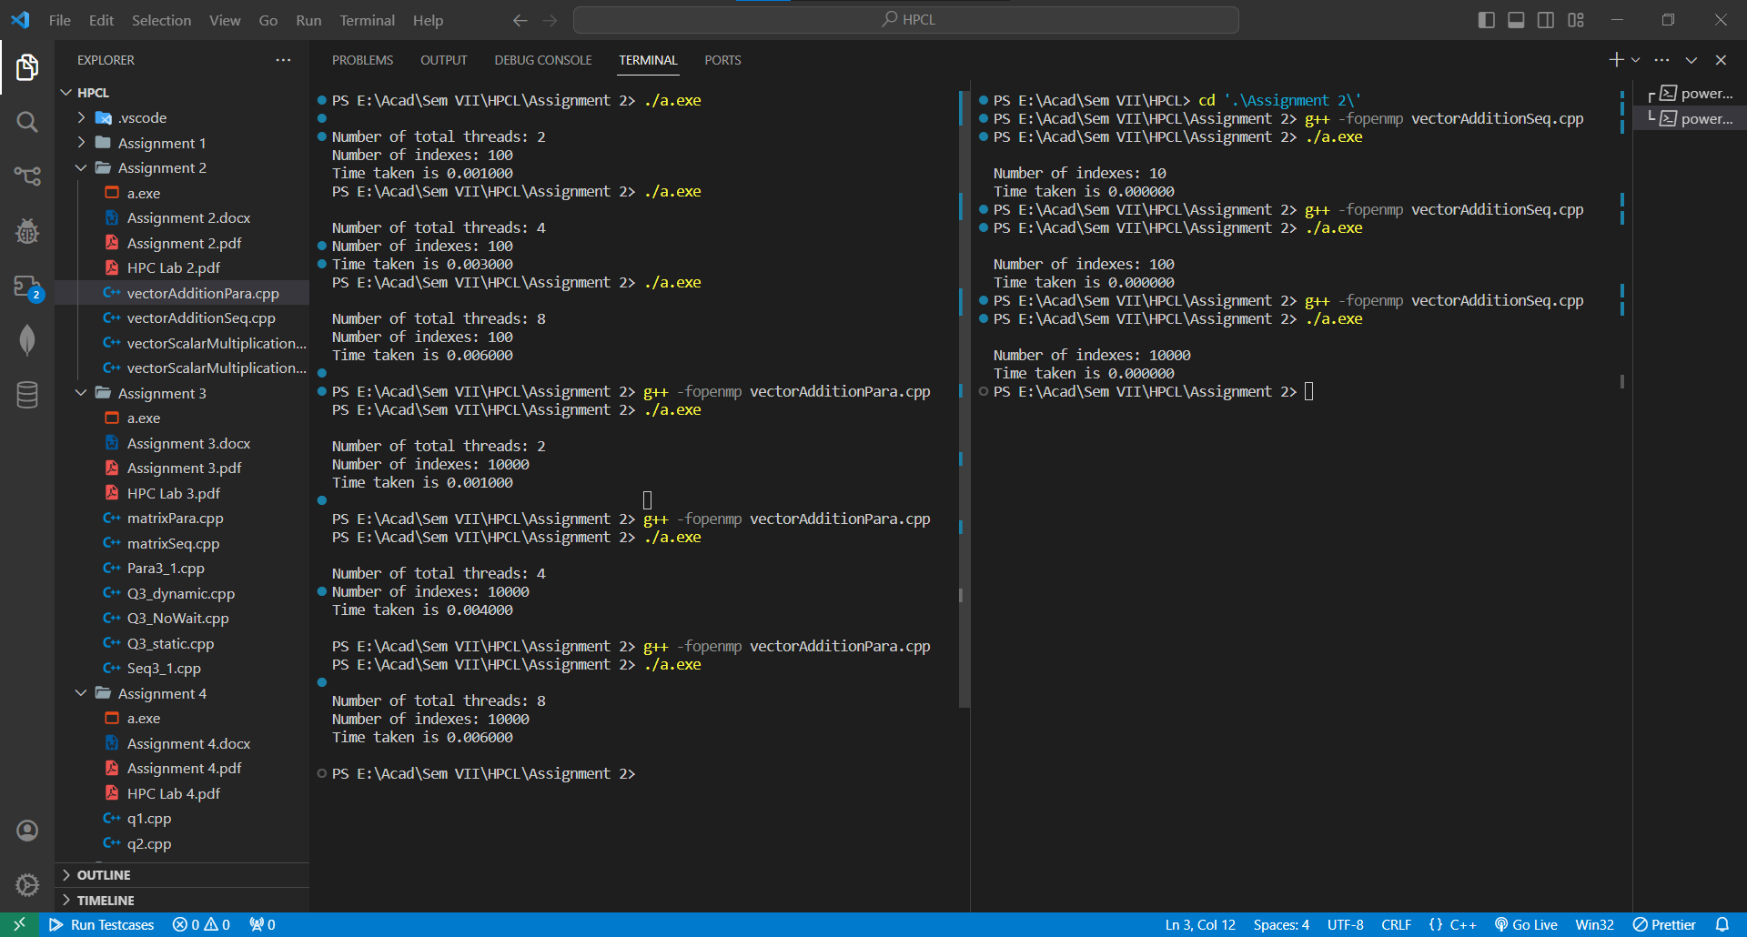

**Information:**

The reduction clause in OpenMP is used to perform a reduction operation on one or more variables across multiple threads. It allows you to automatically compute the final result of a variable after a parallel region. It avoids false sharing.

**Analysis:**



**Problem Statement 2:** Calculation of value of Pi

**Screenshots:**

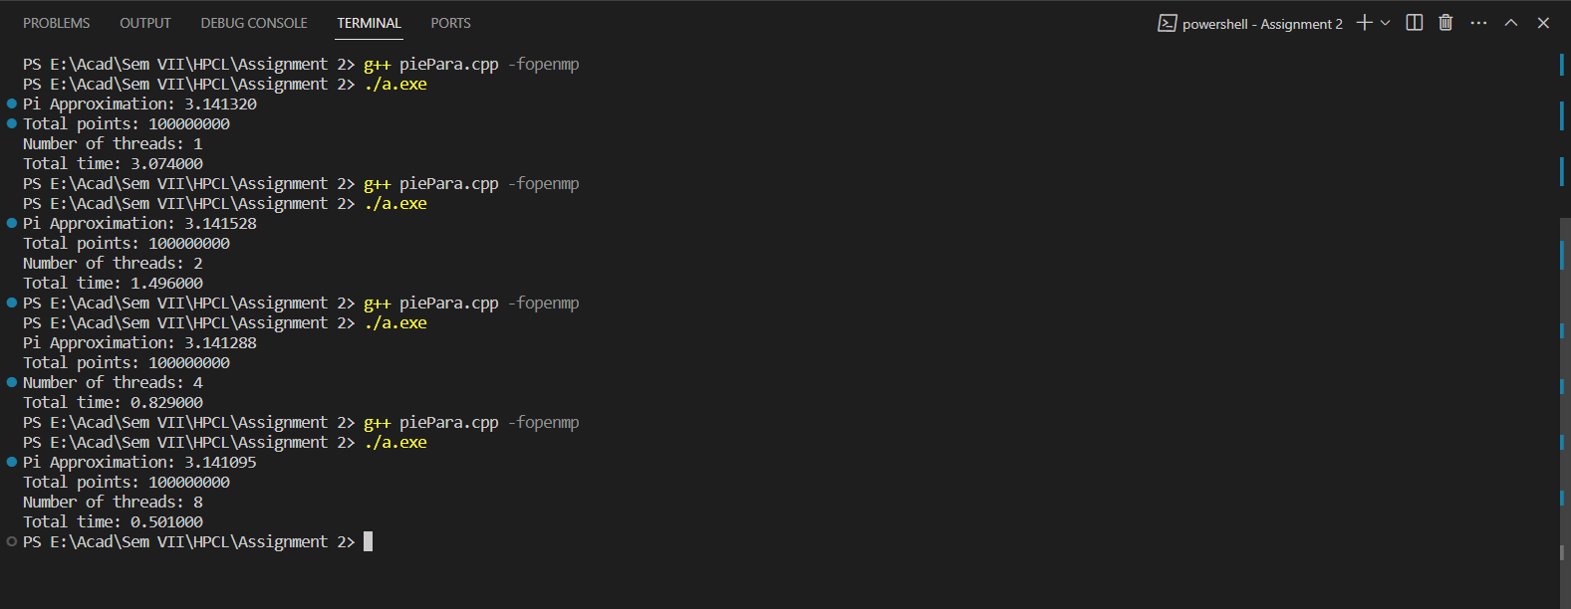

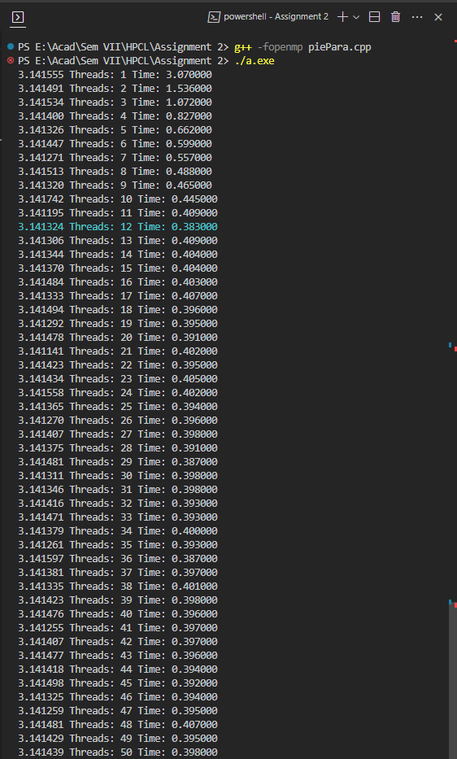

**Information:**

Monte Carlo methods are a way of estimating numerical results through random sampling. The Monte Carlo method for approximating π involves randomly generating points within a square and determining how many falls within a quarter circle inscribed within that square. The ratio of points inside the quarter circle to the total points generated is an approximation of π/4. The final approximation of π is calculated by multiplying the ratio of points inside the circle to the total points by 4, as we are using only one quarter of the unit circle.

**Analysis:**



From the above graph and table, we can see that program with 12 threads has minimum execution time of 0.383ms. And on increasing the threads performance stays the same.

**Speedup (12 threads) =** 3.04/0.383 = 7.98 ≈ 8

**Github Link:** <https://github.com/meetgandhi692/HPC-Lab/tree/ba2b5088ac503136f601c7cbecce99bfc85ca79e/Assignment%202>